Song of Solomon –Psychic Map

Congratulations! Something has gone very, very right! According to Boston Magazine, you go to one of the very best high schools in the state (#5!). According to Forbes, you are living in state that ranks #9 in the world in math and #4 in the world in reading. You are set to succeed…What exactly got you here?

Make a visual presentation—a sort of a “map”—of the places and stories that have shaped your sense of who you are today. How did you get here? What has given you the ability to succeed at Newton South and in the rest of your life?

To do this well, you must…
- Have at least 4 places from your life
- Have 2+ places that shaped your family before you were born
- Have 3+ people on the map
- Use some color
- Use some words
Use at least 2 pieces of
- 8.5 x 11 blank paper

Here’s Grayson Perry’s “Map of Days”

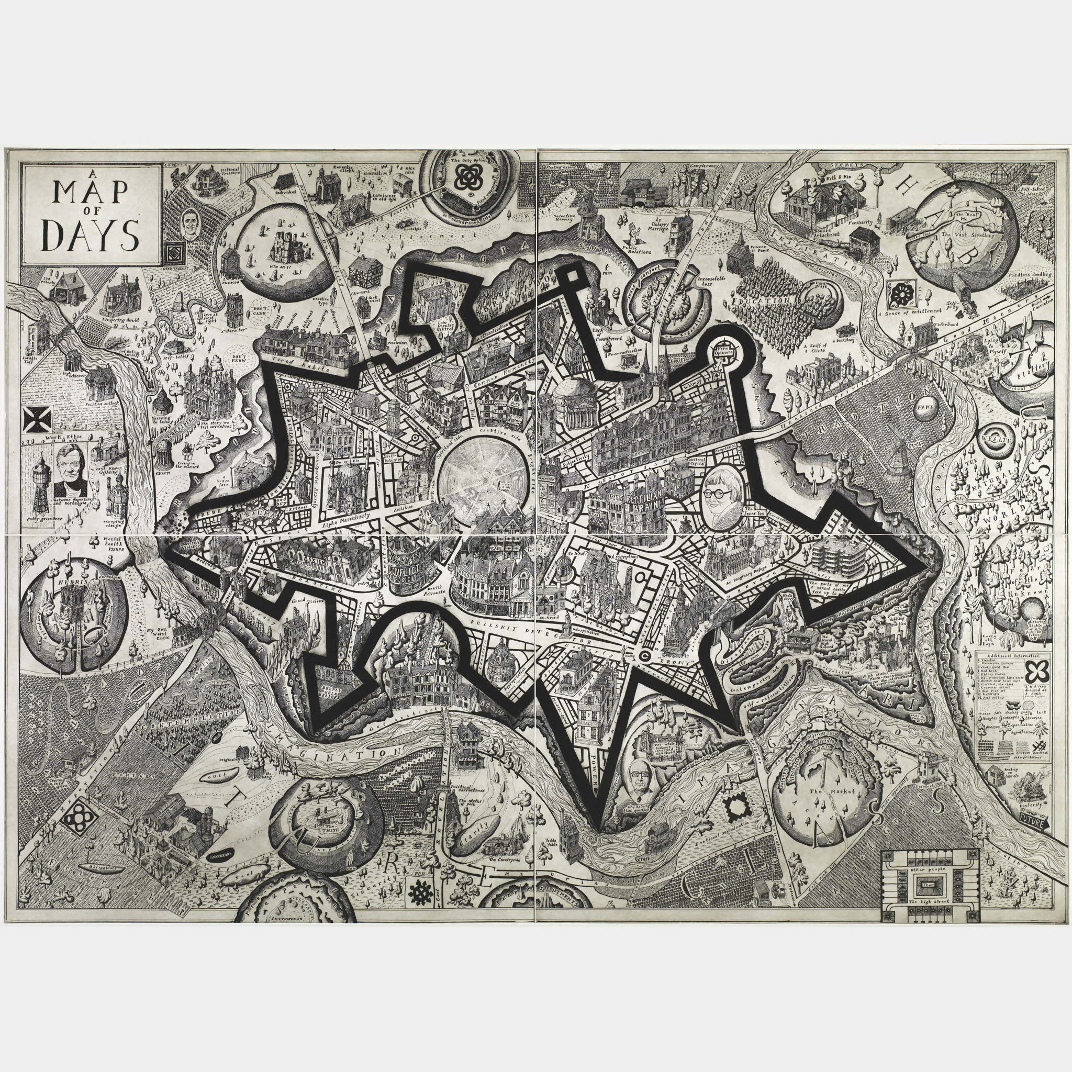

http://www.bostonmagazine.com/best-public-schools-boston-2014-top-50/
http://www.forbes.com/sites/jamesmarshallcrotty/2014/09/29/if-massachusetts-were-a-country-its-students-would-rank-9th-in-the-world/

